1. Go to the SSISDB catalog in SQL Server management studio. Right Click and select the “Active Executions”. The SSISDB catalog can be found under Integration Services Catalogs as shown in below image:

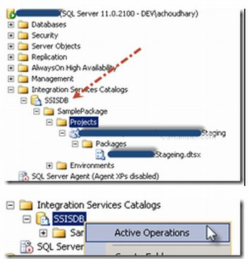

Now a window will appear that will show the currently running packages. Now select your desired package your desired package you want to kill and click STOP.

